LAB SESSION 1

Check ping, traceroute, mtr what kind of packets do they send to discover the intermediate routers? Is it ICMP, TCP, UDP?

What features they use to find routers?

mtr:
It sends a DNS pack to 192.168.0.1, then an arp to check the MAC address

Ping:
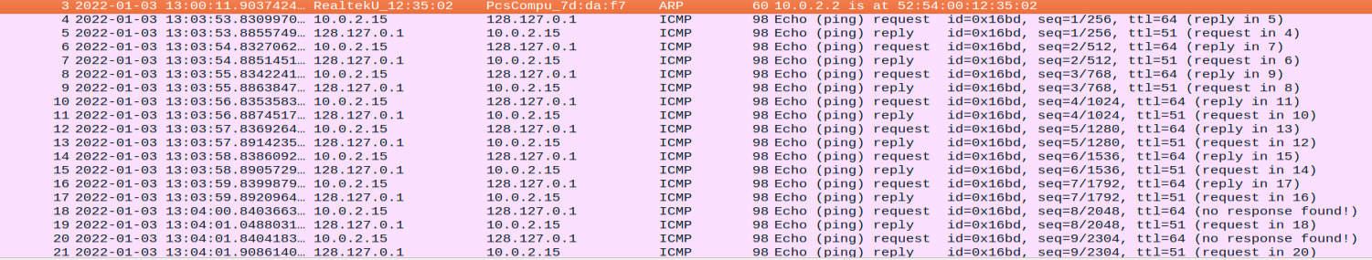
We ping to a random direction and it will send IMCP echo requests, but with no response due to that direction not existing. If we ping to 192.168.0.1(standard direction),then:
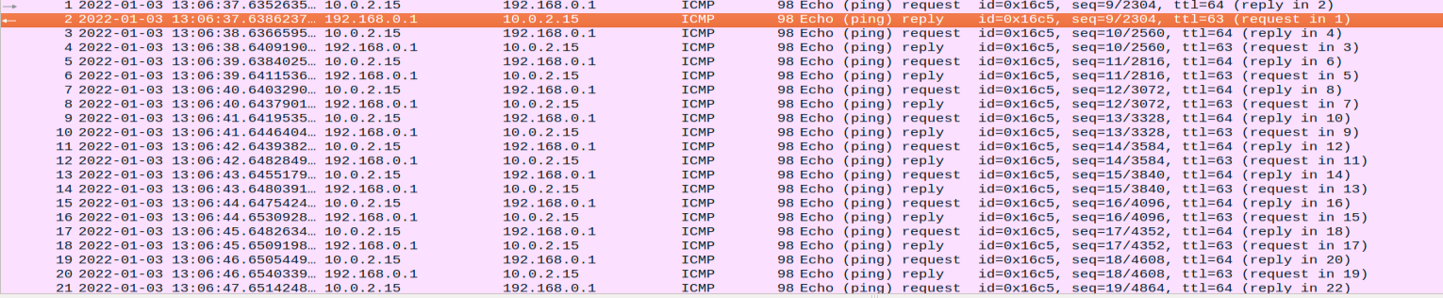
a response will be found and the ttl won't be lower than 63
traceroute:

We now send ICMP packets between the mtr we chose (192.168.0.1) and these two hosts
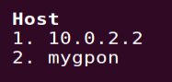
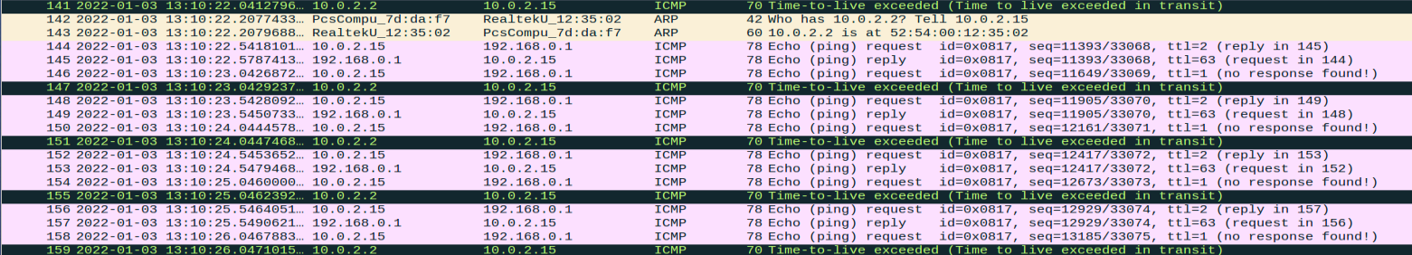
We can also see here that there are some constant ARP checks to find the router and send the requests and replies

Log in to some FTP site, for example ftp.icm.edu.pl or ftp.pwr.wroc.pl using "anonymous" account (provide your email or some random data for the password) -- find out how this password information is sent over the network, use wireshark filters to get just the interesting packets, not all the rubbish that you can listen to on the network

I logged into ftp.icm.edu.pl using username Pedrito and password pedrito (respectively) and I could see the login information just right here (and also that it failed)
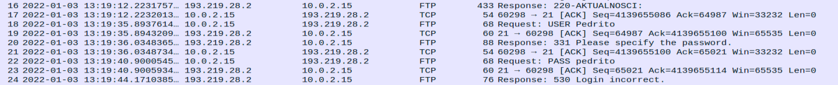
Using username ''Anonymous'' and my email as a password, the login was successful tho.

Access a password protected WWW site: http://dream.ict.pwr.wroc.pl/ssn/secure/ -- use username "ssn" and password "secure". You may of course use a different password and see it fail. Observe how this user/pass information is sent from the web browser to the server.

